Specific Happiness Interventions

We have much more control over our happiness in the moment and in the longer term than we think we do. Try one of these evidence-based happiness interventions and observe the impact on your emotions and your life.
Connect
- Spend extra time with people who energise you – share your happy and sad times
- Play with your pet
- Join a local community group – book club, music group, sporting team, church
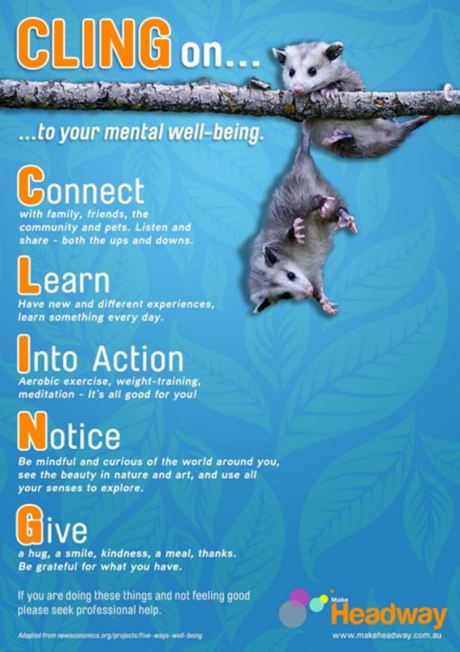
- Tell somebody how much you admire and respect them
Learn
- Something new every day
- A new skill eg singing, wood-working or meditation
- Be interested in local community matters
Into action
- Use your bike or walk rather than the car
- Try your hand at a new sport
- Run around the park with your dog
Notice
- Beauty and excellence
- The little things in life that make you happy or make you laugh
- When you are overthinking or comparing yourself unfavourably to somebody else and redirect your attention elsewhere.
- Experience things with all your senses eg the smell of newly cut grass, the taste of food
Give
- A home-cooked meal or cake
- Compliments – on their clothes, their contribution, the behaviour of their children
- Thanks – keep a gratitude journal where you regularly record 3-5 things you are grateful for
- Kind deeds – perform five random acts of kindness in a single day once a week.
- The gift of forgiveness – to yourself or others
CLING on to your mental well-being by committing 5-10 minutes to your new activity at least once a day. Choose something you find fun and remember to mix it up – our brains need novelty and change.

